Prism Play
Name: ____________________________________

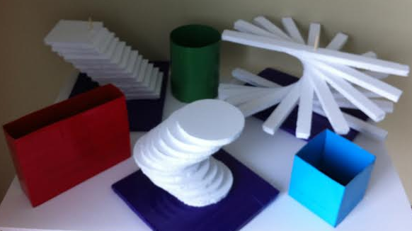

In this activity we will:
Explore the relationship between the AREA and the VOLUME of Prisms.
Learn how to calculate the volume of unique shapes using CAVALIERI’S PRINCIPLE.

Materials:
- Various prism shaped containers
- Various unique shapes to be calculated
- Bag of rice
- Rulers
- Calculator

Some things we need to know:
What is AREA?
____________________________________________________________________________________________________________________________________________________________

What is VOLUME?
____________________________________________________________________________________________________________________________________________________________

First let’s take a look at our normal prisms.

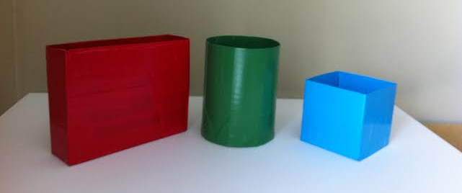

Can you guess if the volume of these prisms are greater than, less than or equal to each other?
Let’s call the prisms by their color: BLUE, GREEN and RED.
In the lines below fill in the names of the prisms according to the order you think they belong and in the circles provided put > , < or =.

___________________________________________________________________________

Now let’s take a look at our unique shapes.

CURVE SPIRAL OBLIQUE

Can you guess if the volume of these shapes are greater than, less than or equal to each other?
Let’s call the shapes: CURVE, SPIRAL and OBLIQUE.
In the lines below fill in the names of the shapes according to the order you think they belong and in the circles provided put > , < or =.

___________________________________________________________________________

Since the VOLUME of a shape can be represented by how much it takes to fill in the space let’s see how much rice can fit in our prisms.

Is it what you thought it would be?

Let’s solve the problem mathematically.

First we find the AREA of the base of the prisms:

BLUE GREEN RED
A =_____________in² A =_______________in² A =_______________in²

Now we find the height:
BLUE GREEN RED
h =_____________in h =_______________in h =_______________in

GENERAL PRISM V = Bh Where B = the area of the base

What did we get for our VOLUMES?
BLUE GREEN RED
V = Bh =_____________in³ V = Bh =_______________in³ V = Bh_______________in³
This proves mathematically what we saw with the rice.

What do we notice about the AREA and the HEIGHT of the two equal prisms?

Even though two totally different shapes, they have the same HEIGHT and their bases have the same AREA. This results in the prisms having the same VOLUME.

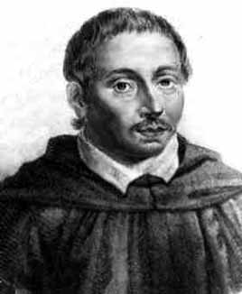
Bonaventura Cavalieri
Italian Mathematician
1598 - 1647

CAVALIERI’S PRINCIPLE
If in two solids of equal attitude the sections made by planes parallel to and at the same distance from their respective bases are always equal, then the volumes of the two solids are equal.
This is what we have shown in the case of the RED and GREEN prisms.

How does this help us find the VOLUME of our other shapes?

Cavalieri’s Principle can also be used as a method of finding the volume of any solid for which cross-sections between parallel planes have equal areas. This includes, but is not limited to cylinders and prisms.

What is a cross-section?
____________________________________________________________________________________________________________________________________________________________
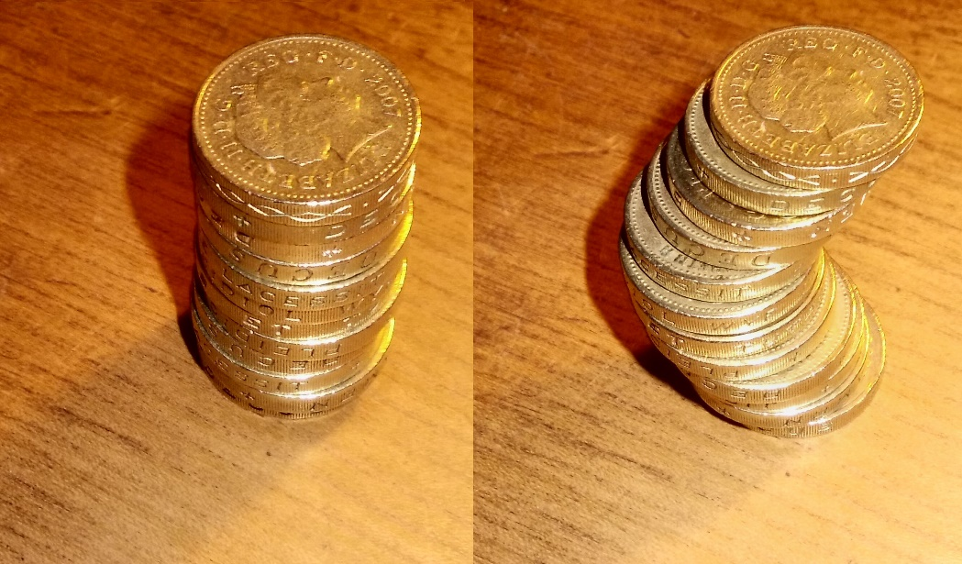

Since all of our unique shapes are between two parallel planes we can treat them as a prism and taking a cross-section of each and measuring the AREA of that cross-section and multiplying it by the height of our shape we can measure the VOLUME.

First let’s find the AREA of the cross-section:

CURVE SPIRAL OBLIQUE
A =_____________in² A =_______________in² A =_______________in²

CURVE SPIRAL OBLIQUE
h =_____________in h =_______________in h =_______________in

CURVE SPIRAL OBLIQUE
V = Bh =____________in³ V = Bh =_____________in³ V = Bh_____________in³

Is it what you thought it would be?

