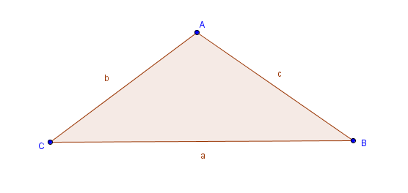
Law of Sines
SinA = SinB = SinC
a b c

- Create triangle ABC using the polygon tool. 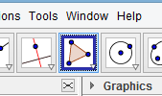
- First we need the measure of each angle. Using the angle tool 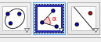 click on ANGLE in the drop down box to measure the degree of each angle.
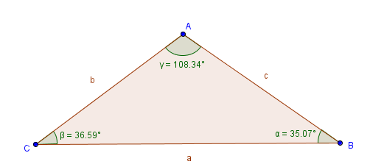
- In a clockwise direction starting with angle A click each vertex in order. This gives us the measure of the angle of the second vertex selected. Continue clockwise around the triangle to measure the remaining angles.

- Measure the length of the sides
a) Click on the side to be measured.
b) Right click and in the drop down box click on OBJECT PROPERTIES.
c) In the PREFERENCES drop down make sure the SHOW LABEL box is checked and choose NAME AND VALUE.
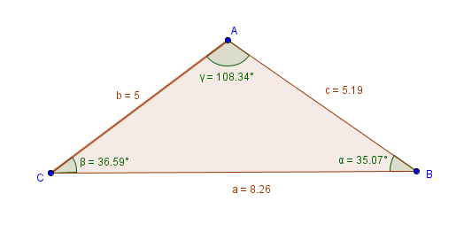
d) Continue for all three sides

5) Find the Sine of all three angles

a) On the INPUT line type sin(ϒ) to find the sine of angle A.
NOTE: You must use parentheses and the angle symbol that corresponds to the angle.

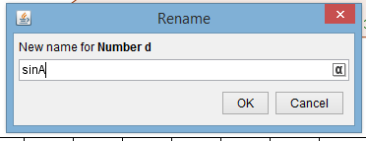
b) The Sine of angle A will come up as d=….. Right click on it and change the name to sinA.

c) Find the sine of the remaining angles and change the names accordingly.

6) Find the ratios

a) On the INPUT line now enter sinA divided by its corresponding side a and hit enter.
b) Rename as RatioA
c) Repeat for RatioB and RatioC.

7) Click and drag the ratios to the graphics screen and move the vertices of the triangle and watch the ratios.

Using The Law of Sines

- Remove the value from one side of the triangle.
a) Click on the side
b) Right click and in the drop down box click on OBJECT PROPERTIES.
c) In the PREFERENCES drop down with the SHOW LABEL box still checked, choose the drop down NAME. This will hide the measure of the side.
- Use the appropriate ratios of the Sine of an angle to its corresponding side and the Sine of the angle that is across from the missing side over the missing side which we’ll call X.

SinA = SinB = SinC ______________ = _________________
a b c X

3) Solve for X X =__________

Let’s play with right triangles and trigonometric functions…

One of the first things we learn in trigonometry is the trigonometric ratios and special right triangles.
Let’s explore them

Soh Cah Toa
SinX = o CosX = a TanX = o
h h a
Questions: Why would using the Sine and Cosine functions not work with every triangle?
_____________________________________________________________________________________

Does Tangent work? _______________

TanX = o Tan_________= ______
a

NOW WITH A RIGHT TRIANGLE
- First let’s make our triangles right triangles. Place one vertex on the point (0,0) and then line up two sides with the X and Y axes.

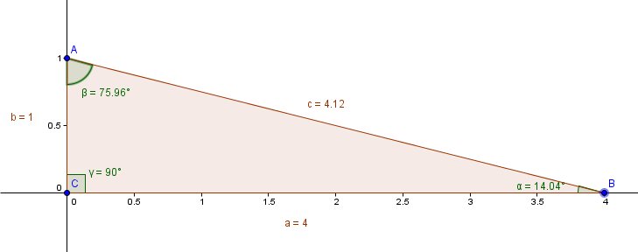

- Let’s see if the trigonometric ratios work. Since we already have the Sine of each angle available lets work with that. The Sine of the angle should equal the ratio of the opposite side of the angle divided by the hypotenuse.

- Find the Sine of angle A using the trigonometric ratio o/h.

- On the INPUT line enter the side opposite angle A (a) divided by the hypotenuse (c).

- Compare to the sinA we already have.

This can be followed up with examples using Cosine and Tangent too.

Special right triangles

